EXP. NO: 16
SIMULATION AND ANALYSIS OF UNIFORM AND NON-UNIFORM DATE: QUANTIZATION USING MATLAB
Objectives:
- To implement and analyze uniform and non-uniform quantization techniques for an analog signal using MATLAB by converting the continuous-amplitude signal into discrete quantization levels.
- To compare the performance of uniform and non-uniform quantization by analyzing their quantized waveforms and quantization errors, and evaluate their effectiveness in representing signals with different amplitude variations.

Procedure :
1. Open MATLAB and create a new script file.
2. Define the simulation parameters, including the sampling frequency, time vector, signal amplitude, signal frequency, and the number of quantization levels.
3. Generate the analog input signal using a sinusoidal waveform.
4. Implement uniform quantization by dividing the signal amplitude range into equal quantization intervals and obtain the uniformly quantized signal.
5. Calculate the quantization error by finding the difference between the original analog signal and the uniformly quantized signal.
6. Implement non-uniform quantization using a companding technique (such as μ-law or A-law) followed by quantization.
7. Recover the non-uniformly quantized signal by applying the corresponding expansion process.
8. Calculate the quantization error for the non-uniform quantized signal.
9. Plot the original analog signal, uniformly quantized signal, non-uniformly quantized signal, uniform quantization error, and non-uniform quantization error using MATLAB subplots.
10. Compare the performance of uniform and non-uniform quantization by analyzing the quantized waveforms and the corresponding quantization errors. 11. Evaluate the effectiveness of both quantization techniques in representing signals with different amplitude variations.
12. Interpret the simulation results and conclude the advantages of non-uniform quantization over uniform quantization for low-amplitude signals.

PROGRAM :
clc;
clear;
close all;
% Input Signal
t = 0:0.001:1;
x = sin(2*pi*5*t);
% Uniform Quantization (8 Levels)
L = 8;
x_uni = round((x+1)*(L-1)/2);
x_uni = (x_uni*2/(L-1))-1;
% Non-Uniform Quantization (μ-law)
mu = 255;
x_comp = sign(x).*log(1+mu*abs(x))/log(1+mu);
x_non = round((x_comp+1)*(L-1)/2);
x_non = (x_non*2/(L-1))-1;
% Plot Results
figure;
subplot(3,1,1)
plot(t,x)
title('Original Signal')
grid on
subplot(3,1,2)
stairs(t,x_uni)
title('Uniform Quantization')
grid on
subplot(3,1,3)
stairs(t,x_non)
title('Non-Uniform Quantization (\mu-law)')
grid on
Output:
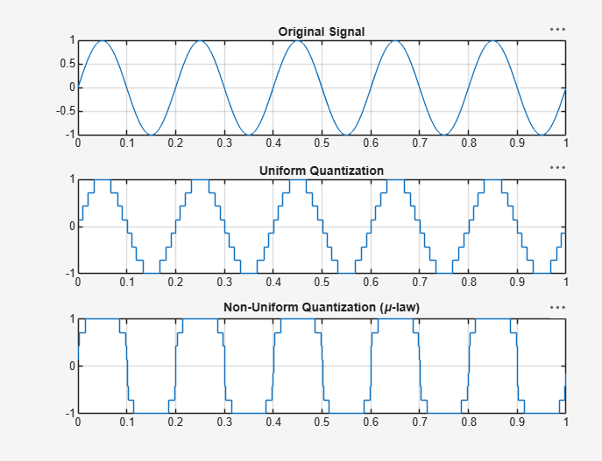
Result:
- The uniform and non-uniform quantization techniques were successfully implemented in MATLAB, and the corresponding quantized signals and quantization error waveforms were obtained.
- The performance comparison showed that non-uniform quantization produced lower quantization error for low-amplitude signals than uniform quantization, resulting in improved signal representation and better overall quantization efficiency.

